**Uninstalling Microsoft Office Desktop Versions (Office 2016/2019/2021)**

**🔹 Method 1: Uninstall via Control Panel**

1. **Open Control Panel**
   * Press Windows + R, type appwiz.cpl, and press **Enter**.

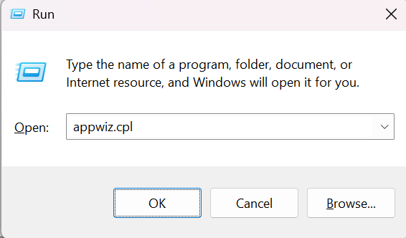

1. **Navigate to Programs and Features**

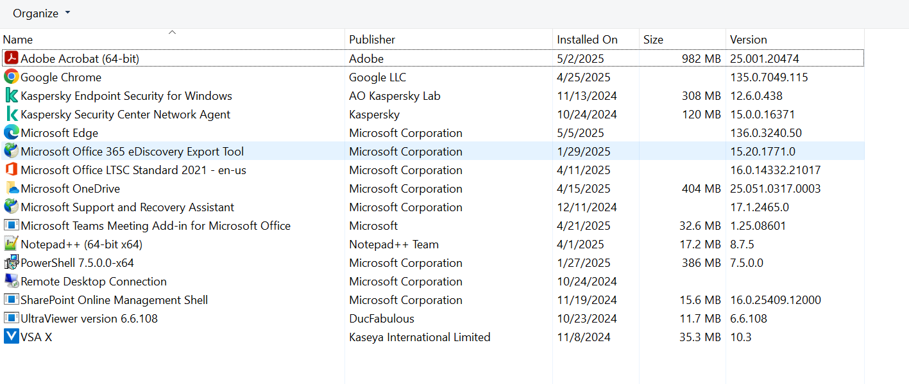

1. **Locate Microsoft Office Installation**
   * Scroll through the list to find your Office installation (e.g., "Microsoft Office Professional Plus 2019").

**4: Uninstall Office (Some May Have Libre Office OR WPS Office) Select the respective and click on Uninstall.**

* + Select the Office entry and click **Uninstall** at the top of the list.

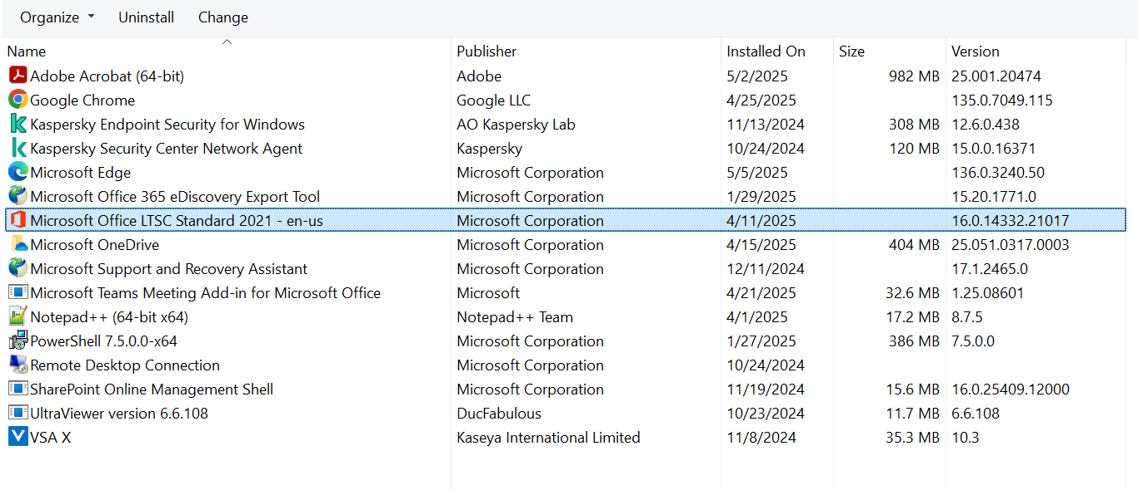

**5: Follow the Uninstallation Wizard**

* + The Office Setup will launch. Choose **"Uninstall"** and follow the prompts until the process completes.

**6: Restart Your Computer**

* Once the uninstallation is complete, restart your PC if prompted.